Competitive Shooters of Lake Norman USPSA May 21st, 2026
COURSE DESIGNER: Ike Starnes

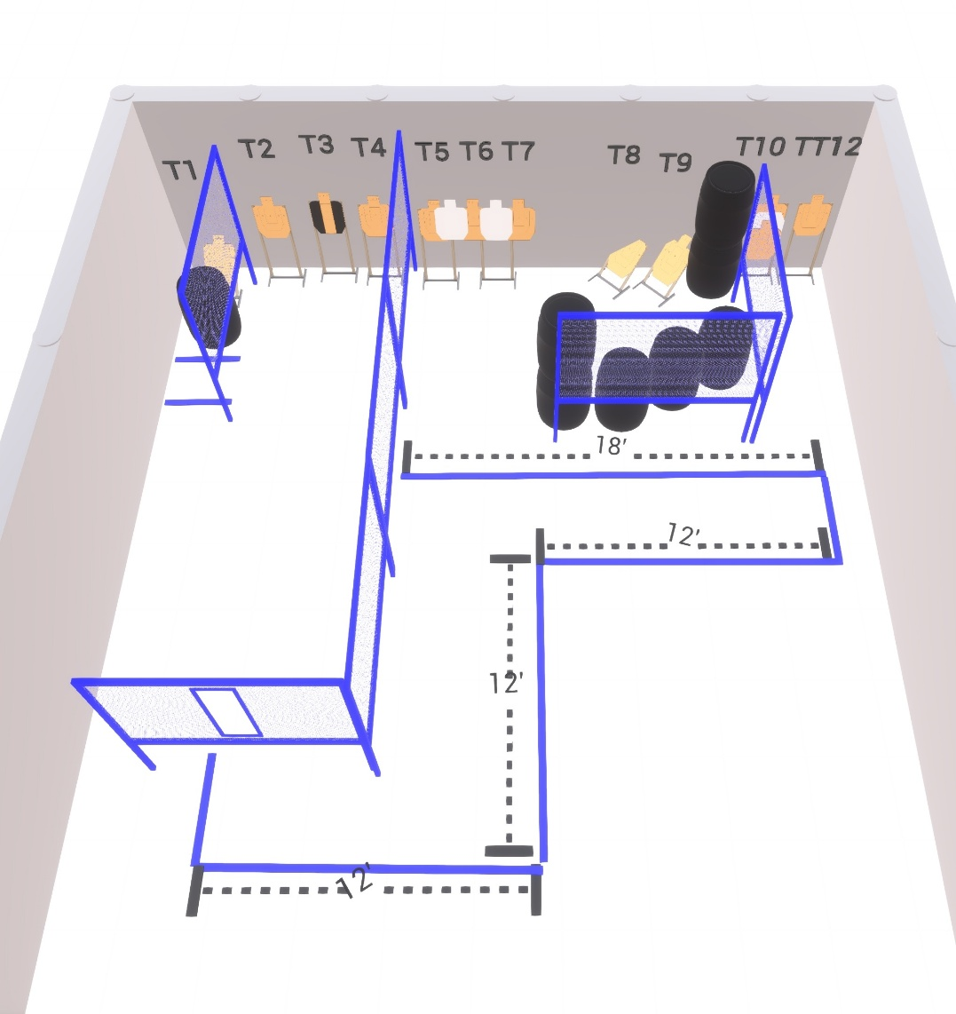

Stage 2 – Blue Suede Shoes
120-point Comstock course.
There are 12 paper targets. Start position is anywhere.
Handgun is loaded and holstered with wrists below belt.
PCC is loaded and held in both hands with stock touching belt.

